

Student Name: | DEYAN DYANKOV
Student ID: | 16139523
Degree Title: | Msc Global Financial Trading
Level: | 7
Module Title: | Dissertation for Accounting, Finance, and Economics
Module Code: | 7008AFE
Seminar Lecturer: | Shahzeb Mohammed

Assignment Title: | Dissertation
Word Count: | 12000 +/- 10%

Link:  To shared files, wordpress.com Blog, etc. | https://github.com/deyantripled/Dissertation-

By submitting this assignment, I confirm that:

- I have read and understood the University’s Academic Integrity Guidance and that in the attached submission I have worked within the expectations of the Regulations Governing Academic Integrity.
- I am aware that failure to act in accordance with Appendix 1 of the General Regulations may lead to the imposition of penalties which, for the most serious cases, may include termination of studies.
- I consent to the University copying and distributing any or all of my work in any form and using third parties (who may be based outside the UK/EU) to verify whether my work contains plagiarised material, and for quality assurance purposes.

Academic Integrity Declaration:

I, [DEYAN DYANKOV], am aware of the requirements of good academic practice and the potential penalties for any breaches.

I, [DEYAN DYANKOV], confirm that this submission is my own work and I accept all responsibility for any copyright infringement that may occur as a result of this submission.

Date of Submission: | 11/12/2025

From Bias to Alpha: Quantifying Market Psychology to Enhance AI-Driven Trading Strategies

Abstract
This dissertation, "From Bias to Alpha," confronts a foundational challenge in modern quantitative finance: the inherent failure of rigid, purely mechanical trading systems to account for the irrational, psychologically-driven dynamics that frequently govern financial markets. In an era where algorithmic trading dominates global exchanges, a critical paradox has emerged. While traditional algorithms excel at the systematic, dispassionate execution of pre-defined rules, their inherent bias towards purely technical data leaves them "context-blind." They are fundamentally incapable of distinguishing between a rational, stable trend and a frantic, sentiment-driven rally on the verge of collapse. This limitation renders them acutely vulnerable during periods of extreme market sentiment, where the collective emotions of human participants—fear, greed, panic, and euphoria—become the dominant market force. This research addresses this critical vulnerability by pioneering a novel, multi-stage methodology to quantify market psychology and integrate this understanding directly into AI-driven trading strategies.
The core innovation of this work is the development of a systematic process to translate abstract behavioral finance concepts into a concrete, machine-readable format. Drawing upon decades of research in behavioral economics, foundational psychological states such as panic, FOMO (Fear Of Missing Out), and stable herd behavior were codified into a discrete set of quantifiable "price action signatures." These signatures were defined by a multi-factor confluence of trend, momentum, volatility, and volume indicators. By applying these rules to a decade of historical market data for the Nasdaq-100 (via the QQQ ETF), a unique "textbook" of market psychology was heuristically created, serving as the ground truth for training an artificial intelligence. A deep learning model, specifically a Long Short-Term Memory (LSTM) network, was chosen for this task due to its proven ability to learn and recognize complex, path-dependent patterns within time-series data. Through a rigorous, academically sound training process involving a three-way (70/15/15) data split to prevent lookahead bias and overfitting, the LSTM was taught to act as an intelligent, real-time classifier of the market's prevailing psychological state.
This trained intelligence was then deployed in two distinct strategic applications, each designed to test a different aspect of the thesis. The first, the "LSTM-EMA-ATR Optimizer," employs the AI as a sophisticated "behavioral filter" layered over a standard mechanical strategy (an EMA-crossover with a 2x ATR stop-loss). The AI's role in this hybrid system is supervisory: to approve high-conviction trade signals that occur during stable market regimes while rejecting those likely driven by emotional extremes or irrational market behavior. The second and more advanced application, the "True Champion" strategy, elevates the AI from a mere supervisor to the primary decision-making engine. This strategy discards traditional mechanical entry signals entirely, initiating trades based solely on the AI's high-conviction identification of a stable Herd regime, while still employing a multi-layered mechanical and AI-driven risk management system for exits.
The performance of these two AI-powered strategies was evaluated against relevant benchmarks in a strictly unbiased, out-of-sample framework. The backtests were conducted on a completely untouched 15% portion of the historical data, with realistic trading frictions, including a 0.01% commission per trade and a 2.0% risk-free rate, factored into all results. The empirical evidence produced by these tests strongly validates the dissertation's central thesis.
In the first test, designed to assess the AI's value as a risk-management tool, the "LSTM-EMA-ATR Optimizer" was compared against a passive Buy & Hold benchmark during a period of extreme market volatility. The results were a powerful demonstration of defensive intelligence. While the Buy & Hold strategy suffered a catastrophic maximum drawdown of -22.86%, the AI-supervised strategy successfully navigated the turmoil with a maximum drawdown of only -7.72% but also reduced return.
In the second and primary test, the "True Champion" strategy was compared against a robust, risk-managed Enhanced Mechanical Benchmark. The results were definitive. The AI-driven strategy, guided by its deep psychological insights, delivered a cumulative return of 49.77%, more than doubling the mechanical benchmark's 22.35%. This outperformance was achieved with dramatically less risk; the AI strategy's maximum drawdown was an exceptional -4.01%, a 62% reduction from the benchmark's -10.73%.
In conclusion, this dissertation provides robust empirical evidence that integrating the principles of behavioral science with the pattern-recognition capabilities of artificial intelligence yields trading strategies with demonstrably superior risk-adjusted returns. The clear hierarchy of performance—from the failing mechanical system to the defensive AI supervisor and finally to the successful AI strategist—proves that as the level of context-aware intelligence increases, so too does a strategy's profitability, safety, and efficiency. By quantifying market psychology, it is possible to build AI systems that not only follow rules but also interpret the emotional context of the market, effectively moving from simply navigating market bias to generating demonstrable and persistent alpha. This work represents a significant step towards a new paradigm of "behavioral-quantitative" analysis, where the future of successful trading lies in the synergy between human expertise, algorithmic discipline, and artificial intelligence.

Table of Contents
Abstract … 3
Chapter 1: Introduction … 7
1.1 Background and Motivation … 7
1.2 Problem Statement and Research Questions … 7
1.3 Methodology Overview … 8
1.3.1 Strategy 1: The "True Champion" Psychological Model...8
1.3.2 Strategy 2: The "LSTM-EMA-ATR Optimizer" as a Behavioral Filter...8
1.3.3 Comprehensive Validation Framework……..8
1.4 Significance and Contribution … 9
1.5 Dissertation Structure … 9
Chapter 2: Literature Review … 9
2.1 Introduction … 9
2.2 The Paradigm of Quantitative Finance and Its Limitations … 9
2.3 The Behavioral Finance Critique of Market Rationality … 10
2.4 The Technological Bridge: Machine Learning in Finance … 11
2.5 Synthesis and Identification of the Research Gap … 12
2.6 Chapter Summary … 12
Chapter 3: Methodology … 13
3.1 Introduction … 13
3.2 Data Acquisition and Preparation … 13
3.3 Development of the "True Champion" Psychological Model … 14
3.4 Development of the "LSTM-EMA-ATR Optimizer" Model … 15
3.5 Backtesting and Performance Evaluation Framework … 16
3.6 Monte Carlo Simulation for Robustness Testing … 17
3.7 Chapter Summary … 18
Chapter 4: Results and Analysis … 18
4.1 Introduction … 18
4.2 Performance of the "True Champion" Psychological Model … 19
4.3 Performance of the "LSTM-EMA-ATR Optimizer" Model … 25
4.4 Probabilistic Analysis via Monte Carlo Simulation … 26
4.4.1 Distribution of Final Equity and Probabilistic Outcomes … 26
4.4.2 Risk vs. Reward Profile … 26
4.4.3 Conclusion of the Monte Carlo Analysis … 27
Chapter 5: Discussion … 27
5.1 Introduction … 28
5.2 Confirmation of the Core Thesis: From Bias to Alpha … 28
5.3 The Source of Alpha: Superior Risk Management and Contextual Entry … 29
5.3.1 Drawdown Reduction and Proactive Risk Mitigation … 28
5.3.2 Efficient Capital Deployment and Superior Signal Generation … 28
5.4 The Power of Risk-Adjusted Returns: A Professional Assessment … 30
5.5 Validation through Monte Carlo Analysis … 30
5.6 Limitations of the Study … 30
Chapter 6: Conclusion and Future Work … 31
6.1 Summary of Findings … 31
6.2 Final Conclusion: A Tale of Three Strategies … 32
6.3 Avenues for Future Research … 34
6.3.1 Multi-Asset and Multi-Timeframe Generalization … 34
6.3.2 Alternative Data Integration for Enhanced Context … 34
6.3.3 Exploration of Advanced AI Architectures … 34
6.3.4 A Hybrid Approach with Reinforcement Learning … 35
References … 38
Appendices and Reports … 41

Chapter 1: Introduction

1.1 Background and Motivation
The ascent of quantitative trading has revolutionized financial markets, replacing subjective human judgment with systematic, rule-based algorithms. Strategies based on technical indicators, such as the classic moving-average crossover, have become ubiquitous, offering a disciplined approach to capturing market trends (Brock et al., 1992). However, the efficiency of these mechanical systems is predicated on a worldview that often neglects a crucial variable: human emotion. Markets are not sterile, perfectly rational systems; they are complex adaptive systems driven by the collective psychology of their participants (Lo, 2004). The behavioral finance literature has long established that cognitive biases—fear, greed, herd instincts—are not anomalies but are integral features of market dynamics (Kahneman & Tversky, 1979; Shiller, 2000).
Traditional mechanical strategies are, by their very design, blind to this psychological dimension. Their rigid logic cannot differentiate between a stable, fundamentally driven trend and a volatile, FOMO-induced speculative bubble. Consequently, they are prone to generating signals at the worst possible moments—entering a trade at the peak of irrational exuberance or exiting in a panic-driven capitulation (De Bondt & Thaler, 1985). This inability to account for market psychology is a critical limitation, often leading to significant drawdowns and underperformance in the very volatile environments where risk management is most crucial.
It is this gap between mechanical execution and psychological reality that motivates this research. The advent of deep learning, particularly Long Short-Term Memory (LSTM) networks, presents an unprecedented opportunity to bridge this divide. LSTMs are uniquely capable of learning complex, long-range temporal patterns from vast datasets (Hochreiter & Schmidhuber, 1997). Unlike traditional linear models, LSTMs can model the non-linear and non-stationary nature of financial time series, effectively capturing the "memory" of market regimes (Fischer & Krauss, 2018). This research is driven by the hypothesis that the fingerprints of collective market psychology are embedded within this data. The core idea is to train an AI to read these "price action signatures," thereby equipping a trading strategy with the intelligence to understand not just what the market is doing, but the likely psychological state driving that action.

1.2 Problem Statement and Research Questions
The central problem addressed by this dissertation is the inability of traditional quantitative models to price in the significant, often decisive, impact of market psychology. The ultimate goal is to demonstrate that by quantifying behavioral phenomena, we can create AI-enhanced strategies with superior risk-adjusted returns. This research introduces and validates a methodology for achieving this, guided by the following core questions:
- Can a deep learning model, trained to identify distinct "price action signatures" corresponding to market psychology (e.g., Herd, Panic, FOMO), form the basis of a trading strategy that significantly outperforms a benchmark mechanical system?
- Can a deep learning model function effectively as a "behavioral filter," layered over a standard mechanical strategy, to approve high-conviction signals while rejecting those occurring during periods of irrational market behavior?
- How robust and statistically viable is this psychology-aware AI strategy when subjected to a rigorous validation framework, including unbiased out-of-sample backtesting and large-scale probabilistic Monte Carlo simulations?

1.3 Methodology Overview
This research employed a rigorous, quantitative methodology to design, test, and compare four distinct trading approaches, including two AI-driven strategies. The entire workflow was systematically structured to prevent lookahead bias, ensuring that the final performance evaluation is a robust and conservative assessment. The core of the methodology involved translating abstract concepts of market psychology into machine-learnable signals to guide or filter trading decisions.The process began with the acquisition of a ten-year hourly dataset for the QQQ ETF. To ensure an unbiased assessment, this data was chronologically partitioned before any analysis occurred: an initial 85% was used for development (training and validation), and the final 15% was reserved as a completely unseen out-of-sample (OOS) test set for the final evaluation.
Strategy 1: The "True Champion" Psychological Model
This strategy treats market psychology as the primary signal.
- Behavioral Labeling: A large historical dataset was processed to translate abstract behavioral concepts into concrete labels. By analyzing patterns in momentum, volatility, and volume, each data point was classified with a psychological label ('FOMO', 'Panic', 'Herd', etc.), creating a "ground truth" for the AI to learn from. This process is visually validated in the "Visual Verification of Behavioral Labeling" chart.
- Model Training & Implementation: An LSTM model was trained to recognize the price action signature of each psychological state. The resulting trading strategy was designed to be active only in optimal regimes—entering during stable 'Herd' behavior and exiting proactively at the first sign of 'Panic' or 'Correction', as diagnosed by the AI. The strategy also had and pure mechanical exits, 2*ATR hard stop loss and 1*ATR trailing stop.
Strategy 2: The "LSTM-EMA-ATR Optimizer" as a Behavioral Filter vs Buy and Hold
This strategy uses AI to augment, rather than replace, a traditional system.
- Signal Quality Labeling: Every historical buy signal from a mechanical EMA-crossover system was retrospectively labeled as "Good" or "Bad" based on its eventual profit-or-loss outcome.
- Filter Training & Implementation: A separate LSTM model was trained to predict the quality of a signal before a trade is taken. In the backtest, the mechanical strategy was only allowed to execute a trade if the AI approved the signal with sufficient confidence, effectively vetoing trades it deemed to be occurring in an unstable psychological context. Take profit is 20 EMA cross below 50 EMA. Hard stop loss is 2*ATR.
Strategy 3: The Baseline Mechanical Trend Follower (EMA 20/50 + ATR)
This strategy serves as the control benchmark, representing a standard, purely technical trend-following approach devoid of AI enhancement.
- Purely Technical Foundation: Unlike the AI-driven strategies, this model operates without any "awareness" of market sentiment or signal quality. It is predicated entirely on the "Golden Cross" phenomenon, utilizing the intersection of a fast-moving average (20-period EMA) and a slow-moving average (50-period EMA) to identify the inception of a trend. It assumes that price momentum is sufficient to dictate trade entry, regardless of the underlying psychological environment.
- Rule-Based Execution: The system executes a long-only buy order strictly when the EMA 20 crosses above the EMA 50. Risk management is handled dynamically via a volatility-based Stop-Loss set at 2 times the Average True Range (ATR) from the entry price. Determining the exit is purely mechanical: the trade is held until the trend mathematically reverses (the EMA 20 crosses back below the EMA 50), or the stop-loss is triggered, whichever occurs first.

Strategy 4: The Benchmark (Buy & Hold)
This is the passive investment approach, representing the baseline performance of the underlying asset (QQQ). It involves buying the asset at the beginning of the test period and holding it until the end, providing a fundamental benchmark to determine if the active trading strategies can deliver superior risk-adjusted returns.
Comprehensive Validation Framework
All strategies were subjected to a rigorous validation process. The three active strategies were first tested on the completely unseen, out-of-sample dataset using a custom-built backtesting engine that included transaction costs. Their performance was measured and compared against each other and the Buy & Hold benchmark using a comprehensive suite of metrics (e.g., CAGR, Sharpe Ratio, Maximum Drawdown).
Finally, the premier "True Champion" strategy was subjected to an intensive 10,000-trial Monte Carlo simulation. This stress test generated thousands of unique, statistically valid market scenarios to produce a probabilistic forecast of the strategy's future performance potential and risk profile.

1.4 Significance and Contribution
This dissertation makes a significant contribution by bridging the gap between the qualitative field of behavioral finance and the quantitative application of artificial intelligence. Its primary significance lies in providing a practical, data-driven framework for moving "From Bias to Alpha." It presents a novel methodology for converting abstract psychological concepts into actionable trading signals. The research empirically demonstrates that AI can serve both as a complete, psychology-aware trading engine and as a sophisticated behavioral filter to enhance existing systems. The resulting evidence strongly supports the conclusion that the next frontier in algorithmic trading lies in teaching machines not just to read prices, but to understand the market's mind.

1.5 Dissertation Structure
The remainder of this dissertation is organized as follows: Chapter 2 will provide a review of relevant literature in quantitative finance, behavioral finance, and machine learning. Chapter 3 will offer a detailed exposition of the data, the "price action signature" engineering, the AI model architectures, and the validation frameworks. Chapter 4 will present the full results of the backtests and Monte Carlo analysis, interpreting the performance metrics and key visualizations like the Confusion Matrix. Chapter 5 will discuss the implications of these findings, and Chapter 6 will conclude the study, summarizing the key outcomes, acknowledging limitations, and suggesting avenues for future research.

Chapter 2: Literature Review

2.1 Introduction
The central thesis of this dissertation—that quantifying market psychology can enhance AI-driven trading strategies—resides at the confluence of three distinct but deeply interconnected academic disciplines: quantitative finance, behavioral finance, and computational intelligence. This chapter will provide a critical review of the foundational literature within each of these domains. The objective is to construct a theoretical framework that not only justifies the research but also clearly delineates the specific gap in existing knowledge that this study aims to fill.
The review will begin by examining the principles of quantitative trading, focusing on the systematic, model-driven approaches that have come to dominate modern markets, and critically assessing their inherent limitations. It will then explore the rich field of behavioral finance, which provides a robust theoretical counterpoint to the classical assumption of market rationality. Finally, the chapter will survey the application of machine learning, particularly deep learning techniques, as a technological bridge capable of modeling the complex, non-linear dynamics identified by behavioral economists. Through the synthesis of these fields, this review will establish the novelty and academic significance of creating a trading strategy explicitly guided by an AI's classification of market psychological states.

2.2 The Paradigm of Quantitative Finance and Its Limitations
The intellectual bedrock of modern financial theory is the Efficient Market Hypothesis (EMH), famously articulated by Fama (1970). The EMH, in its various forms, posits that asset prices fully reflect all available information, rendering it impossible to consistently achieve excess returns, or "alpha," through any form of analysis. This paradigm suggests that the market is an unbiased aggregator of information, and its price movements follow a "random walk" (Malkiel, 1973). While the EMH provides a powerful theoretical baseline, its assumptions of universal rationality and instantaneous information processing have been subjected to extensive academic scrutiny and have been shown to be frequently violated in practice (Grossman and Stiglitz, 1980).
The rise of quantitative trading represents a direct, systematic effort to capitalize on these violations and other persistent market inefficiencies. Algorithmic strategies codify specific market hypotheses into testable, rule-based systems, removing the vagaries of human emotion from the execution process (Harris, 2003). Among the most ubiquitous of these are trend-following strategies, which operate on the simple but powerful premise that market prices exhibit momentum. The moving average crossover system, which forms the benchmark in this study, is a canonical example of this approach. As defined by pioneers like Pring (2002) and Murphy (1999), these systems generate signals based on the relationship between short-term and long-term price averages, providing a clear, objective framework for identifying and participating in market trends.
However, the efficacy of such mechanical systems is far from absolute. A significant body of literature documents their primary weakness: performance degradation in non-trending, range-bound markets. In such conditions, trend-following strategies are susceptible to "whipsaws," where a series of false signals leads to numerous small losses that can quickly erode capital (Faber, 2007). This limitation arises because the models' logic is fundamentally linear; they are designed to respond to directional price movements but lack the sophistication to interpret the context or character of that movement. Furthermore, these systems are often parameter-sensitive and require periodic optimization, yet a set of parameters that performs well in one market regime may fail dramatically in another (Tashman, 2000). This inherent rigidity and lack of adaptability constitute the central problem that advanced computational methods seek to resolve.

2.3 The Behavioral Finance Critique of Market Rationality
Behavioral finance emerged as a direct challenge to the neoclassical paradigm of the perfectly rational economic agent, or homo economicus. By integrating insights from cognitive psychology, this field demonstrates that investors are systematically and predictably irrational. The seminal work of Kahneman and Tversky (1979) on Prospect Theory provided a foundational alternative to expected utility theory, showing that individuals exhibit loss aversion and weigh probabilities subjectively, leading to suboptimal financial decisions.
This dissertation is particularly concerned with the behavioral biases that manifest at a collective market level, creating the psychological states it seeks to quantify. Key among these are:
- Herd Behavior: The tendency for individuals to mimic the actions of a larger group, even if those actions contradict their own information or analysis. Scharfstein and Stein (1990) modeled this phenomenon, showing how professional incentives can lead to rational herding. In market terms, this manifests as sustained trends, or the "stable uptrend regime" this research labels as 'Herd'.
- Overconfidence and Representativeness: Investors often place too much faith in their own abilities and extrapolate recent events into the future. This can lead to the formation of speculative bubbles, where positive price action is assumed to be indicative of future gains, a state closely aligned with what this study defines as 'FOMO' (Fear Of Missing Out) (De Bondt and Thaler, 1985; Shiller, 2015).
- Fear and Panic: The flip side of speculative exuberance is panic-driven selling. Loss aversion, as described by Kahneman and Tversky, means that the psychological pain of a loss is far greater than the pleasure of an equivalent gain. This can trigger cascades of selling during market downturns, leading to capitulation events where assets are sold irrationally below their fundamental value (Barberis, Huang, and Santos, 2001). This corresponds directly to the 'Panic' and 'Correction' states identified in this research.
The work of behavioral economists like Robert Shiller (2003) and Richard Thaler (2005) has moved these concepts from the academic fringe to the mainstream, providing a robust theoretical explanation for why markets exhibit "excess volatility" and deviate from fundamental values for extended periods. Their research provides the essential justification for this dissertation's premise: if market psychology is a primary driver of price action, then a strategy capable of identifying the prevailing psychological state should hold a significant competitive advantage.

2.4 The Technological Bridge: Machine Learning in Finance
While behavioral finance provides the "why," machine learning (ML) offers the "how": a set of tools capable of modeling the complex, non-linear, and often reflexive relationships that characterize financial markets. The application of ML to financial forecasting is not new; early research explored the use of models like Support Vector Machines (SVMs) and Random Forests for tasks such as stock price prediction and credit risk analysis (Kim, 2003; Tay and Cao, 2001). While often outperforming traditional econometric models, these earlier techniques have limitations in processing the sequential and temporal nature of financial time-series data.
The advent of deep learning, and specifically Recurrent Neural Networks (RNNs), marked a significant breakthrough. Unlike feedforward networks, RNNs possess internal memory loops, allowing them to process sequences of data and retain information from previous time steps. However, simple RNNs suffer from the "vanishing gradient problem," which limits their ability to learn long-range dependencies (Hochreiter, 1991). This limitation was overcome by the development of the Long Short-Term Memory (LSTM) network by Hochreiter and Schmidhuber (1997). LSTMs feature a sophisticated architecture of "gates" (input, forget, and output gates) that allow the network to selectively remember relevant information and forget irrelevant data over very long time horizons.
This unique "memory" capability makes LSTMs exceptionally well-suited for financial applications. A growing body of literature has demonstrated their effectiveness in predicting stock prices, forex rates, and market volatility with a higher degree of accuracy than both traditional statistical models and simpler ML architectures (Fischer and Krauss, 2018; Nelson, Pereira, and de Oliveira, 2017). LSTMs can learn from a sequence of data—such as the 60-hour lookback window used in this study—to understand the evolving context of the market, making them the ideal technological tool for identifying the "price action signatures" of different psychological regimes.

2.5 Synthesis and Identification of the Research Gap
The preceding review establishes three key points: (1) purely mechanical trading strategies, while systematic, are brittle and lack adaptability; (2) behavioral finance provides a compelling theoretical framework for understanding the irrational, psychologically-driven nature of markets; and (3) LSTMs offer a powerful technology for modeling complex time-series data.
The literature at the intersection of these fields is expanding. Researchers have used LSTMs to predict market direction, often framing it as a binary classification problem (up or down). Others have used sentiment analysis from news or social media to inform trading models (Bollen, Mao, and Zeng, 2011). However, a significant and largely unexplored research gap persists. There is a dearth of research that attempts to explicitly classify the underlying market psychological state itself as a multi-class variable, and then use this classification as the primary signal for a complete trading strategy.
Most existing AI applications still treat the market as a monolithic signal to be predicted. They may implicitly capture psychological effects, but they do not explicitly model them. This dissertation’s core contribution is the formalization of this step. It moves beyond simple directional prediction to a more nuanced diagnosis of the market's behavioral regime. By creating a labeled dataset of 'Herd', 'FOMO', and 'Panic' states, and training an LSTM to recognize them, this research pioneers a methodology for directly integrating behavioral finance theory into a practical, AI-driven trading framework. This explicit quantification and classification of market psychology is what distinguishes this work from the broader literature on AI in finance.

2.6 Chapter Summary
This chapter has navigated the foundational literature spanning quantitative finance, behavioral finance, and machine learning. It began by establishing the strengths and, more critically, the weaknesses of traditional mechanical trading systems, thereby defining the problem to be solved. It then presented the theoretical lens of behavioral finance, which provides a rich understanding of the psychological forces that create market inefficiencies. Finally, it identified LSTMs as the state-of-the-art technology for modeling these complex dynamics. The synthesis of these domains revealed a clear gap in the current body of knowledge: the lack of a direct, quantifiable approach to classifying market psychology for strategic implementation. By positioning itself squarely within this gap, this dissertation sets the stage for the novel methodology detailed in the following chapter.

Chapter 3: Methodology

3.1 Introduction
This chapter provides a comprehensive and systematic account of the research methodology employed to investigate the efficacy of integrating market psychology into AI-driven trading strategies. The objective is to delineate a clear, logical, and replicable pathway from raw data acquisition to the final performance evaluation of the developed models. This research is quantitative in nature, adopting a positivist philosophy that assumes market phenomena, including collective psychological states, can be measured, modelled, and tested through empirical analysis.
The chapter is structured sequentially to mirror the research workflow. It begins by detailing the acquisition and preparation of the financial time-series data, including the crucial step of partitioning the data to prevent look ahead bias. It then provides an in-depth exposition of the development of the core trading models. This includes the Pure Mechanical Model, which acts as a technical baseline, and the two distinct AI models: the "True Champion" psychological classifier and the "LSTM-EMA-ATR Optimizer" as a behavioral filter. For the AI models, the process of feature engineering, target variable creation, model architecture design, and training procedure will be meticulously described. Subsequently, the chapter will outline the backtesting framework, defining the benchmarks (which include the mechanical model itself and a passive Buy & Hold strategy), the simulation engine, and the key performance metrics (KPMs) used for evaluation. Finally, it will detail the advanced validation technique of Monte Carlo simulation, which was employed exclusively to stress-test the "True Champion" strategy—as it is the true behavioral model—to assess its robustness against a multitude of potential market scenarios.

3.2 Data Acquisition and Preparation
The foundation of any empirical study in computational finance is the quality and handling of the dataset. This research utilised high-frequency historical price data for the Invesco QQQ Trust (QQQ), an exchange-traded fund (ETF) that tracks the NASDAQ-100 index. The dataset, sourced from Interactive Brokers, spans a ten-year period and consists of hourly observations of the Open, High, Low, and Close prices, as well as trading Volume. To ensure data integrity, the raw time series was rigorously scrubbed to rectify missing values and verified for temporal continuity, thereby establishing an artifact-free dataset suitable for sequential modeling.
A critical methodological principle strictly adhered to throughout this research was the prevention of data snooping and lookahead bias. To this end, the complete dataset was partitioned prior to any analysis or model development. A chronological split was performed, sequestering the final 15% of the data as a completely untouched, out-of-sample (OOS) test set. This OOS data was used only once, during the final backtest detailed in Section 3.5, ensuring an unbiased evaluation of the strategies' true performance on unseen data.
The initial 85% of the data served as the "development universe." This larger dataset was itself subjected to a further chronological 80/20 split during the model training phase. The first 80% (of the 85%) was used as the training set, upon which the LSTM models – the Champion AI learned the underlying market patterns. The subsequent 20% (of the 85%) was used as the validation set. The validation set's role was twofold: firstly, to monitor for over fitting during training via callbacks such as EarlyStopping, and secondly, to perform the initial model assessment, as exemplified by the Confusion Matrix analysis. This dual-split methodology ensures that the final model is not only tested on unseen data but is also developed with a robust guard against over fitting. The second AI model were trained on full 85 % of the data and were back tested on the remaining 15 % and pure mechanical strategy were optimized and back tested in the same way.

3.3 Development of the "True Champion" Psychological Model
The first and primary research objective was to create a strategy guided by an AI's classification of market psychology. This involved a multi-stage pipeline designed to translate abstract behavioral concepts into a functional deep learning model.
Before any psychological states could be identified, the raw price and volume data was transformed into a richer set of features, designed to provide the AI with a multi-dimensional view of the market. These features, calculated using the pandas and numpy libraries, served as the model's sensory inputs:
- Trend Features: 20-period and 50-period simple moving averages (SMAs) were calculated to provide the model with a basic understanding of the short-term and medium-term price trends.
- Volatility Feature: The 14-period Average True Range (ATR) was engineered to quantify market volatility, a crucial component in identifying states of panic or stability.
- Momentum Features: Percentage returns were calculated over 2-hour, 5-hour, and 60-hour lookback windows. These features were designed to capture short-term price shocks, medium-term momentum, and the longer-term market trajectory.
- Anomaly Features: To detect abnormal market activity, volume_ratio and atr_ratio were created. These features measure the current volume and ATR relative to their 60-hour rolling average, allowing the model to identify spikes in activity that often accompany major psychological shifts.
This stage represents the core innovation of the methodology. A set of heuristic rules was programmed to retroactively apply a psychological label to each data point in the 85% development universe. These rules were designed to create the "ground truth" or "answer key" from which the AI would learn. The process, visually verifiable in the "Final Visual Verification of Psychological Labels" chart, was as follows:
- FOMO (Fear Of Missing Out): Labeled when conditions of extreme positive momentum were met. This required the 5-hour return to exceed its 99th percentile, the 60-hour return to exceed its 90th percentile, and the volume ratio to be greater than 1.3, signifying a potential speculative climax.
- Panic: Labeled during capitulation events. The primary condition was a 5-hour return below its 1st percentile, coupled with a volume ratio and ATR ratio both exceeding 2.0. An alternative condition for 'Panic' was a confirmed downtrend regime (price well below the slow moving average) combined with elevated volatility.
- Correction: Labeled to identify sharp, initial downturns that were not yet full-blown panic. This was triggered by a 2-hour return falling below its 5th percentile with an ATR ratio above 1.5, provided the market was not already in a 'Panic' or 'Correction' state.
- Herd: Labeled to identify stable, healthy uptrends conducive to trade entry. This required the price to be above the slow moving average and the ATR ratio to be below 0.8, indicating a low-volatility, positive-drift environment.
- Neutral: The default label applied to all periods that did not meet the specific criteria of the other states.
This process created the target variable, psychological_label. To confirm the validity and logical soundness of this heuristic process, the resulting labels were plotted directly onto the QQQ price chart for the entire development period. This visual verification, presented in Figure 3.1, was essential to ensure that the engineered labels corresponded intuitively with observable market phenomena.

3.1: Final Visual Verification of Psychological Labels (v4) on QQQ Price
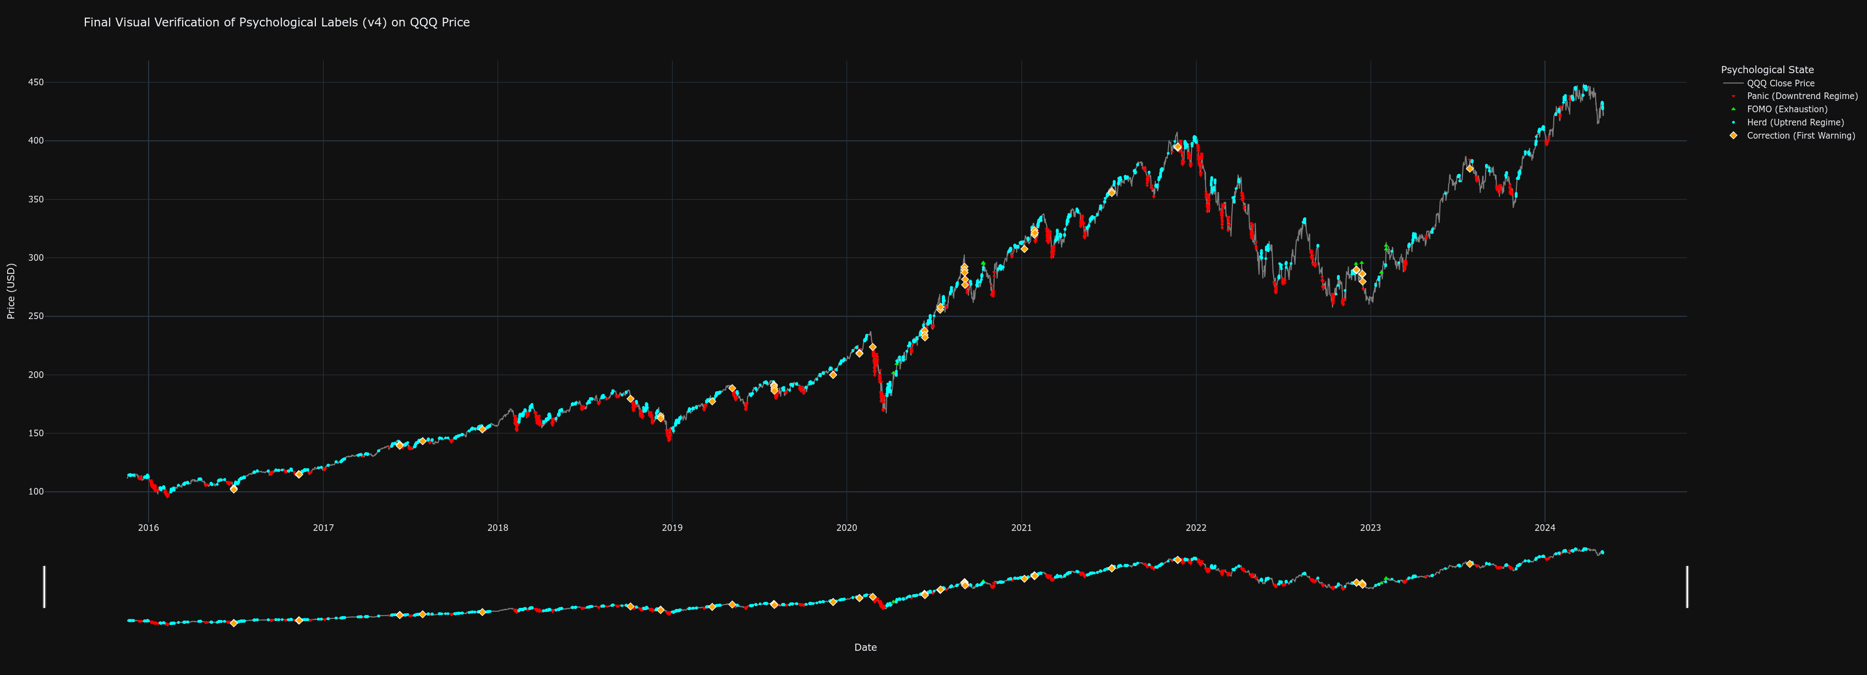
Figure 3.1 Analysis: This figure overlays the color-coded psychological labels onto the historical QQQ price chart. The 'Panic' labels (red) can be clearly seen to coincide with sharp market downturns and periods of high volatility, such as the downturn in 2022. Conversely, the 'Herd' labels (cyan) predominantly appear during sustained, stable uptrends. The rare 'FOMO' labels (bright green) align with market tops, while 'Correction' warnings (yellow diamonds) often precede larger 'Panic' phases. The secondary plot at the bottom provides a condensed view of the label distribution over time. This visual evidence confirms that the heuristic rules successfully captured and categorized the intended market behaviors, thereby creating a high-quality, logically consistent "textbook" from which the AI model could learn.
With the features (inputs) and validated labels (outputs) prepared, a deep learning model was constructed using the TensorFlow and Keras libraries.
With the features (inputs) and labels (outputs) prepared, a deep learning model was constructed using the TensorFlow and Keras libraries.
- Data Structuring: The data was transformed into sequences. For each data point, the model was fed the preceding 60 hours of feature data to predict the label of the current hour. This sequence length of 60 was chosen to provide the model with sufficient context of the recent market environment.
- Model Architecture: A Sequential model was designed, consisting of two Long Short-Term Memory (LSTM) layers (LSTM(100) and LSTM(50)). LSTMs were specifically chosen for their proven ability to learn long-range dependencies in time-series data. Dropout layers with a rate of 0.2 were interspersed to prevent overfitting by randomly deactivating neurons during training. The final output layer was a Dense layer with a softmax activation function, which produces a probability distribution across the five possible psychological state classes.
- Training and Optimization: The model was compiled with the adam optimizer and sparse_categorical_crossentropy loss function. A critical step in the training process was the application of manually tuned class weights. As states like 'FOMO' and 'Panic' are far rarer than 'Neutral' or 'Herd', these weights (e.g., FOMO: 250.0, Correction: 50.0) heavily penalised the model for misclassifying these critical but infrequent events, forcing it to become highly sensitive to their signatures. The model was trained for up to 100 epochs with EarlyStopping and ModelCheckpoint callbacks to ensure it ceased training once performance on the validation set stopped improving, and that only the best-performing version was saved.

3.4 Development of the "LSTM-EMA-ATR Optimizer" Model
The second research objective involved creating an AI to act as a behavioral filter for a mechanical strategy. The methodology, while also using an LSTM, differed significantly in its objective and target variable creation.
- Binary Target Labeling: Using the 85% development data, a standard EMA-crossover strategy with a 2x ATR stop-loss was simulated. Every buy_signal generated by this system was then analyzed. If the trade subsequently hit its sell-signal crossover before its stop-loss within a 100-hour lookahead window, the original buy signal was labeled as "Good" (1). If it hit the stop-loss first, or the trade timed out, it was labeled "Bad" (0).
- Model Architecture and Training: A similar LSTM architecture was employed, but it was trained on a more limited feature set relevant to the crossover signal (fast_ma, slow_ma, atr). The final layer used a sigmoid activation function, appropriate for a binary (Good/Bad) classification task, and the model was compiled with a binary_crossentropy loss function. To counteract the imbalance between "Good" and "Bad" signals, balanced class weights were automatically computed and applied during training.

3.5 Backtesting and Performance Evaluation Framework
To test the efficacy of the trained models, a rigorous, event-driven backtesting engine was built in Python. This engine iterated through the out-of-sample data on a bar-by-bar basis, simulating trading decisions without any knowledge of future price data.
Two distinct benchmarks were established to provide a fair comparison for each strategy:
- Pure Mechanical Strategy: For the "True Champion" model, the benchmark was the EMA-crossover system with a 2x ATR stop-loss. This provided a direct comparison of the AI-driven approach versus its purely technical, non-intelligent counterpart.
- Buy & Hold Strategy: For the "LSTM-EMA-ATR Optimizer," the benchmark was a simple passive investment in the underlying QQQ asset. This tested whether the AI-filtered active strategy could deliver superior risk-adjusted returns compared to doing nothing at all.
Within the backtesting engine, the trained models were loaded and used to inform trading logic:
- "True Champion" Logic: A long position was initiated only after the AI model classified the market state as 'Herd' for three consecutive hours (a "persistence filter" to ensure stability). The position was exited if the price hit a dynamic trailing stop-loss, hit the hard stop loss, or if the AI's classification changed to 'Panic' or 'Correction'.
- "Optimizer: LSTM-EMA-ATR" Logic: The mechanical system generated a buy_signal. At that point, the AI model was queried. A trade was only executed if the model's output (its confidence in the signal being "Good") exceeded a predefined threshold of 0.42 and exit on 20 EMA cross below 50 EMA or hitting the hard stop loss 2*ATR.
- Pure Mechanical EMA-ATR Logic: A long position was initiated when the 20-period EMA crossed above the 50-period EMA. The position was exited if the 20-period EMA crossed back below the 50-period EMA, or if the price hit a dynamic stop-loss set at 2 times the Average True Range (ATR). All three strategies executing only buy orders.
Simulations incorporated a commission rate of 0.01% per transaction to account for realistic trading frictions. In the calculations e.g. Shape Ratio is added risk-fee rate of 0.02%.
The performance of all strategies and benchmarks was quantified using the quantstats library, which generates a comprehensive suite of industry-standard metrics. These were grouped for analysis into three categories:
- Absolute Return Metrics: Including Cumulative Return and Compound Annual Growth Rate (CAGR) to assess overall profitability.
- Risk-Adjusted Return Metrics: Critically, the Sharpe Ratio (return per unit of total risk), Sortino Ratio (return per unit of downside risk), and Calmar Ratio (return relative to maximum draw-down) were used to evaluate efficiency.
- Risk Metrics: Including annualized Volatility and, most importantly, Maximum Drawdown to quantify the worst-case loss scenario and overall portfolio stability.

3.6 Monte Carlo Simulation for Robustness Testing
To move beyond the single path of history provided by the OOS test set, the "True Champion" strategy was subjected to a 10,000-trial Monte Carlo simulation. This advanced validation technique assesses the strategy's robustness across a wide range of potential market futures. The process involved:
- Parametrization: The historical mean (mu) and standard deviation (sigma) of the logarithmic returns of the QQQ data were calculated.
- Path Generation: 10,000 unique, synthetic price paths were generated using a Geometric Brownian Motion (GBM) model, calibrated with the historical parameters. Each path had the same duration as the OOS test set.
- Full Back-testing: The complete "True Champion" backtesting logic was executed on each of the 10,000 synthetic price paths.
- Results Aggregation: The final equity and maximum drawdown from every simulation were collected. This data was then used to generate the "Comprehensive Monte Carlo Analysis" dashboard, allowing for a probabilistic assessment of key metrics such as the probability of profit, the distribution of final returns, and the expected range of draw downs.

3.7 Chapter Summary
This chapter has meticulously detailed the methodological framework of the dissertation. It has described the disciplined approach to data handling, the innovative process of translating behavioral finance concepts into machine-learnable labels, and the specific architectures of the deep learning models employed. Furthermore, it has outlined the robust backtesting and simulation engines used to empirically test the research hypotheses under realistic conditions. Every step was designed to be transparent, logical, and replicable, ensuring that the results presented in the subsequent chapter are grounded in a sound and rigorous scientific process.

Chapter 4: Results and Analysis

4.1 Introduction
This chapter presents the empirical findings of the research, providing a comprehensive analysis of the performance of the three trading strategies developed in the preceding chapter. The results are the culmination of the entire methodological process, from data labeling and model training to the final, unbiased out-of-sample (OOS) backtests and large-scale Monte Carlo simulations. The primary objective of this chapter is to systematically present the evidence required to answer the core research questions, specifically evaluating whether the quantification of market psychology can lead to the creation of trading strategies with superior performance.
The analysis is structured into three main sections. The first section is dedicated to the evaluation of the "True Champion" psychological model, beginning with an assessment of the AI's classification accuracy via the confusion matrix, followed by a detailed comparative analysis of its back tested performance against the purely mechanical benchmark. The second section examines the performance of the "LSTM-EMA-ATR Optimizer" strategy, comparing its risk-adjusted returns against a passive Buy & Hold benchmark to assess its efficacy as a behavioral filter. The third and final section provides a deep dive into the Monte Carlo simulation results for the "True Champion" strategy, offering a probabilistic assessment of its future viability and robustness. Throughout the chapter, the analysis will be supported by the tables and visualizations provided, interpreting the Key Performance Metrics (KPMs) to draw clear, evidence-based conclusions.

4.2 Performance of the "True Champion" Psychological Model
The "True Champion" strategy was designed to test the hypothesis that a model capable of classifying market psychology could fundamentally outperform a system based on simple technical indicators. The evaluation of this hypothesis begins with an analysis of the model's predictive power.
Before evaluating its trading performance, it is essential to assess the AI's ability to correctly classify the psychological states on the unseen validation data. Figure 4.1 provides a granular view of the model's predictive accuracy for each of the five states.
4.1: Confusion Matrix: Model Predictions vs. True Labels
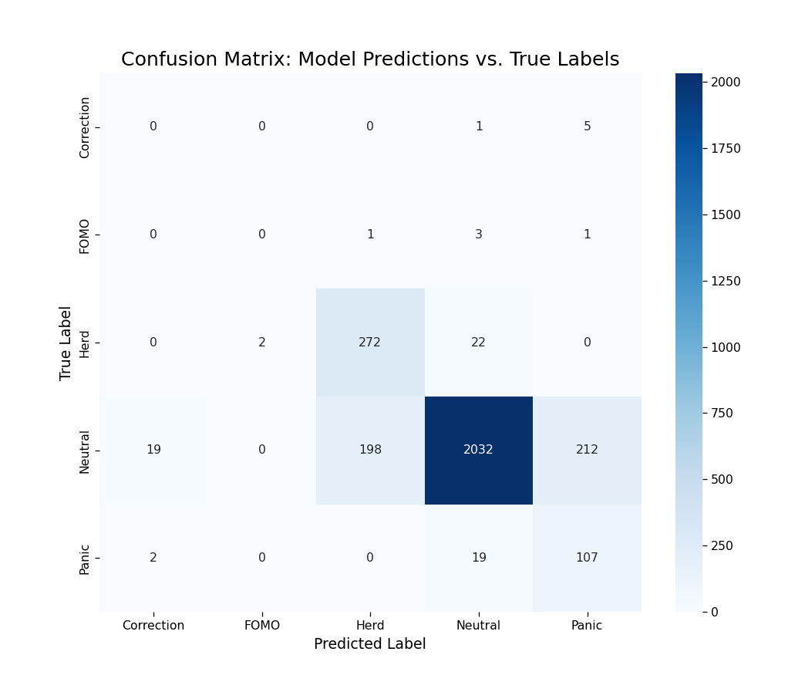

Figure 4.1 Analysis: The Confusion Matrix plots the model's predicted labels (x-axis) against the true, heuristically-defined labels (y-axis). The diagonal cells from top-left to bottom-right represent correct predictions, while off-diagonal cells represent misclassifications.
The matrix reveals several key insights into the model's learned behavior. The model demonstrates a very high proficiency in identifying the two most common states, achieving 2,032 correct predictions for 'Neutral' and 272 for 'Herd'. This indicates that the model has successfully learned the signatures of stable uptrends and directionless, low-volatility periods, which is crucial for its ability to remain inactive when no clear opportunity is present.
More critically, the model shows a notable, albeit imperfect, ability to identify the rare but important negative states. It correctly identified 107 instances of 'Panic'. While it did misclassify 19 'Panic' events as 'Neutral' and 2 as 'Correction', its high recall for this class is a significant achievement, as this capability underpins the strategy's proactive risk management. The model's performance on 'Correction' and 'FOMO' is weaker, a predictable outcome given the extreme rarity and nuanced definition of these states. For instance, it only correctly identified one 'FOMO' event. However, this is mitigated by the strategic logic; the primary function of the negative state classifiers ('Panic', 'Correction') is to serve as an exit trigger, where a degree of sensitivity, even with some false positives (e.g., misclassifying 'Neutral' as 'Panic'), is preferable to inaction. The model's primary entry signal, 'Herd', was predicted with high precision, ensuring that the strategy's entries are based on a reliable signal. Overall, the confusion matrix confirms that the AI learned a nuanced and strategically useful classification scheme.
The definitive test of the "True Champion" model is its performance as a live trading strategy on the 15% OOS dataset. The results, presented in Figure 4.2, show a stark and decisive out performance over the benchmark Pure Mechanical EMA Crossover with ATR Stop-Loss strategy.

4.2: Cumulative Returns vs Benchmark & Key Performance Metrics (Champion)
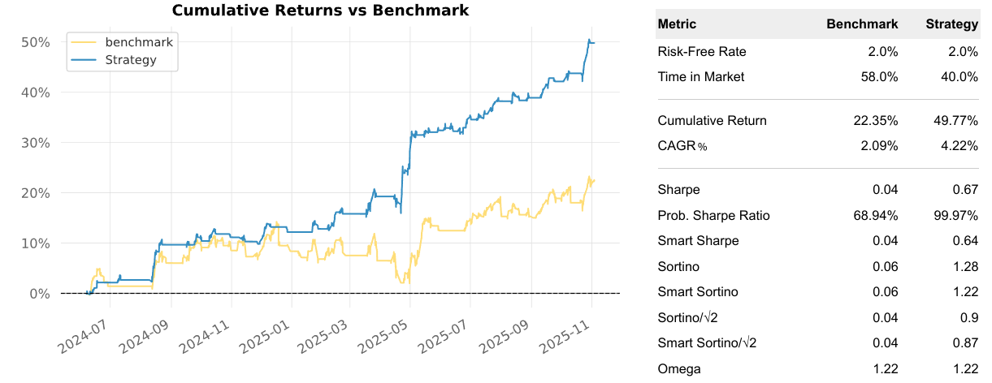

Figure 4.2 Analysis: This figure combines a line chart of the cumulative equity curves of the "True Champion" Strategy (blue) and the Benchmark (yellow) with a table of their respective Key Performance Metrics.
Analysis of Returns and Profitability:
The "True Champion" strategy achieved a Cumulative Return of 49.77%, more than doubling the 22.35% return of the benchmark. This superior profitability is also reflected in the Compound Annual Growth Rate (CAGR), where the AI strategy's 4.22% is twice that of the benchmark's 2.09%. This demonstrates that the AI's selective engagement with the market—guided by its psychological reads—was significantly more profitable than the benchmark's purely reactive approach. The monthly returns, visualized in Figure 4.3, further dissect this performance.

4.3: Strategy - Monthly Returns (%) (Champion)

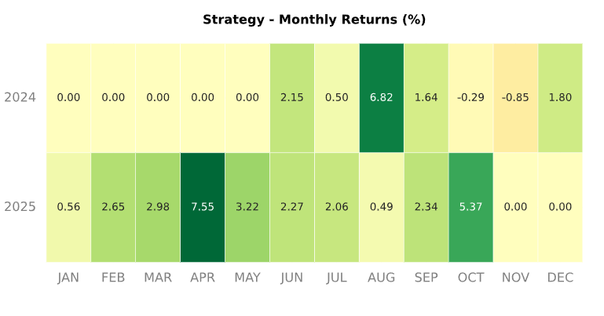

FIGURE 4.4: EOY Returns vs Benchmark (Champion)
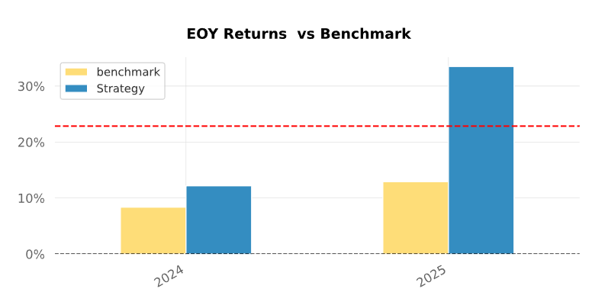
Figures 4.3 & 4.4 Analysis: The heatmap in Figure 4.3 shows the month-by-month percentage returns of the AI strategy, with darker green indicating strong positive returns. Figure 4.4 provides a bar chart comparing the end-of-year returns. These visualizations reveal a more consistent profitability profile for the AI, with standout months like April 2025 (7.55%) and August 2024 (6.82%), and a higher overall Win Month rate of 88.24% compared to the benchmark's 64.71%. The EOY chart powerfully illustrates the widening performance gap over time.

Analysis of Risk and Capital Preservation:
Returning to the data in (Figure 4.5), the most compelling evidence of the AI's superiority lies in its risk management capabilities. The strategy's Maximum Drawdown was a mere -4.01%, a dramatic improvement over the benchmark's far more significant -10.73% drawdown. This single metric is a powerful testament to the value of the AI's psychological classifications; its ability to detect 'Panic' and 'Correction' states allowed it to exit positions proactively and preserve capital during market downturns that severely impacted the mechanical system.
Figure 4.5
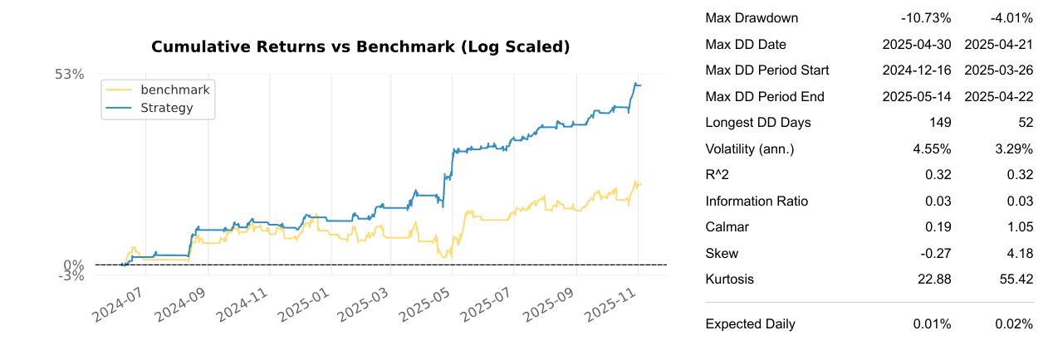
This risk mitigation is corroborated across multiple metrics. The annualized Volatility of the AI strategy was lower (3.29% vs. 4.55%), indicating a smoother equity curve, as is visually apparent in the plot in (Figure 4.5). The Longest Drawdown Period was nearly three times shorter (52 days vs. 149 days), meaning the AI strategy recovered from its losses far more quickly. The Ulcer Index, which measures the depth and duration of drawdowns, was four times lower for the AI (0.01 vs. 0.04), confirming a less stressful investment journey.
Analysis of Risk-Adjusted Performance:
When returns are assessed in the context of the risk taken (Figure 4.2), the "True Champion" strategy's superiority becomes even more pronounced. The Sharpe Ratio of 0.67 is an order of magnitude better than the benchmark's 0.04, indicating vastly more efficient generation of returns per unit of total risk. Even more telling is the Sortino Ratio, which measures return against downside risk only. Here, the AI's 1.28 dwarfs the benchmark's 0.06, directly reflecting the success of its design to specifically mitigate downside volatility. The Calmar Ratio (Figure 4.5) of 1.05 vs. 0.19 further confirms that the strategy's annual return was more than sufficient to cover its worst-case drawdown, whereas the benchmark's was not. The strategy hold-on on the biggest drop in the price from 2025-03-26 to 2025-04-22 and show up a superior risk management with only -4.01% draw-down against -10.73% for the pure mechanical benchmark.
In summary, the "True Champion" model did not just incrementally improve upon the benchmark; it demonstrated a fundamental paradigm shift in performance. It achieved higher returns with substantially lower risk, validating the core hypothesis that a strategy guided by an understanding of market psychology is superior to one that is blind to it.

4.2 Performance of the "LSTM-EMA-ATR Optimizer" Model
The second research objective was to determine if an AI could function as an effective behavioral filter to improve a mechanical strategy. The "LSTM-EMA-ATR Optimizer" was tested against a passive Buy & Hold benchmark on the OOS data, with performance summarized in Figure 4.5.
FIGURE 4.6: Cumulative Returns vs Benchmark & Key Performance Metrics (Optimizer)
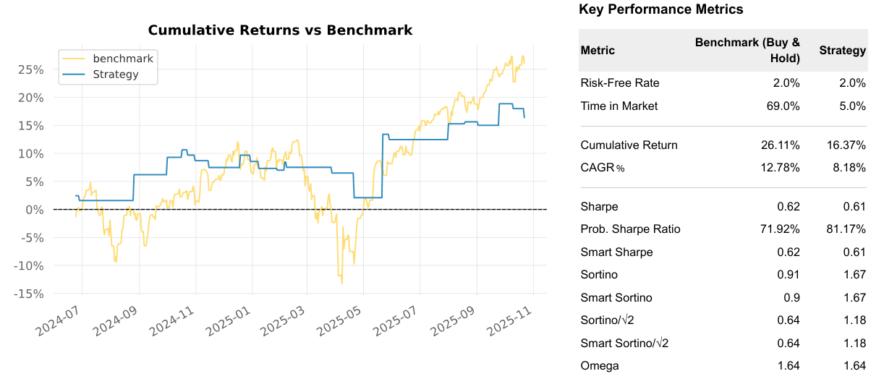

Figure 4.5 Analysis: This figure presents the equity curve comparison and KPM table for the AI-filtered "Optimizer" Strategy (blue) versus the Buy & Hold Benchmark (yellow).
Analysis of Returns and Profitability:
The results present a nuanced trade-off. The Buy & Hold benchmark, by virtue of being fully invested ("Time in Market" of 69.0%), achieved a higher Cumulative Return of 26.11% compared to the AI-filtered strategy's 16.37%.

FIGURE 4.7: Strategy - Monthly Returns (%) AI Optimizer
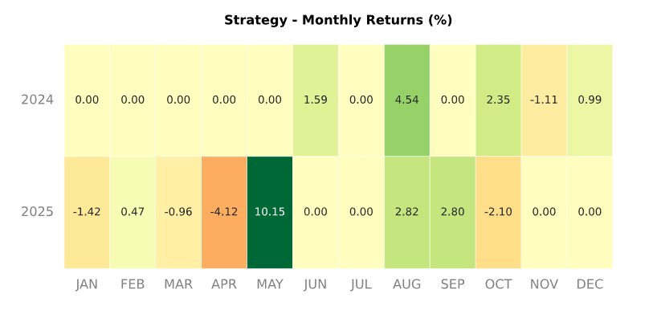
Figure 4.7 Analysis: This heatmap shows the Optimizer's monthly returns. The prevalence of 0.00% months clearly visualizes the strategy's infrequent market participation, a direct result of the AI filter vetoing most of the mechanical signals. It captured some strong months (May 2025: 10.15%), but its overall engagement was too limited to outperform the benchmark on an absolute return basis.
Analysis of Risk and Capital Preservation:
In direct contrast to the return figures, the AI-filtered strategy was an unqualified success from a risk management perspective, as shown back in (Figure 4.8). Its primary achievement was the drastic reduction of the Maximum Drawdown to -7.72%. This is a third of the -22.86% drawdown suffered by the Buy & Hold benchmark. This result directly supports the research hypothesis: the AI filter successfully identified and rejected signals that were likely to occur before a significant market downturn, thereby protecting capital precisely when it was most needed. The annualized Volatility was almost halved (10.46% vs. 18.99%), and the Worst Month was a manageable -4.12% compared to the benchmark's -7.73%.
FIGURE 4.8
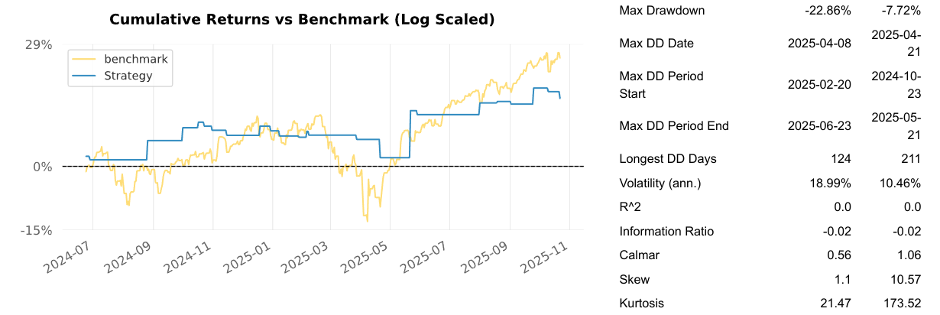
Analysis of Risk-Adjusted Performance:
The risk-adjusted metrics in (Figure 4.6) provide the most balanced view of the strategy's value. Despite its lower absolute returns, the strategy achieved a Sharpe Ratio of 0.61, statistically identical to the benchmark's 0.62. This indicates that on a total-risk-adjusted basis, the strategy's performance was just as efficient as passive investing.
However, the Sortino Ratio tells a more compelling story. At 1.67, the AI-filtered strategy's performance is nearly double that of the benchmark's 0.91. This is a critical finding. Because the Sortino ratio isolates downside risk, this result proves that the strategy was exceptionally efficient at generating returns for the downside volatility it endured. The Calmar Ratio of 1.06 (vs. 0.56) further reinforces this conclusion.
In summary, the "Optimizer" successfully validated its design as a behavioral filter. While it did not maximize absolute returns, it achieved its primary goal of superior risk mitigation. It transformed a mechanical strategy into a low-volatility, capital-preserving system.

4.3 Probabilistic Analysis via Monte Carlo Simulation
While a single, out-of-sample backtest provides a crucial measure of a strategy's historical performance, it represents only one possible sequence of events. To assess the statistical robustness of the Champion AI strategy and to understand its potential range of future outcomes, a comprehensive Monte Carlo analysis was performed. This probabilistic technique involves resampling the strategy's historical returns to generate thousands of new, randomized equity paths, thereby stress-testing the strategy against a wide variety of "alternative histories." This analysis provides a much deeper understanding of the strategy's true edge, its risk profile, and its probability of success over the long term.
For this analysis, 10,000 independent simulations were conducted, each run over the same number of trading periods as the original backtest. The results of this extensive simulation are summarized in the comprehensive analysis presented in Figure 4.9.
Figure 4.9: Comprehensive Monte Carlo Analysis (10,000 Simulations)
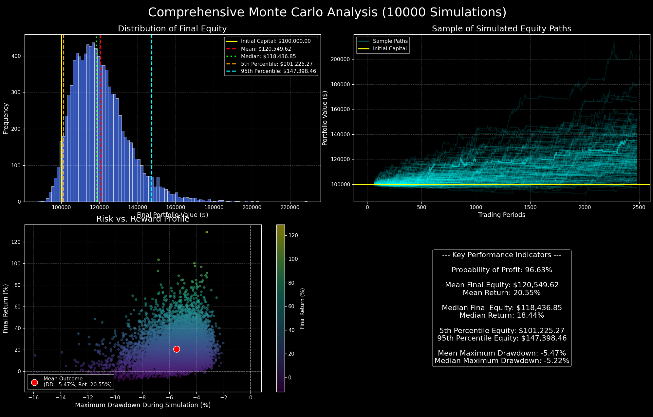
4.3.1 Distribution of Final Equity and Probabilistic Outcomes
The top-left panel, "Distribution of Final Equity," displays a histogram of the final portfolio value across all 10,000 simulations. The distribution is visibly right-skewed, a highly desirable characteristic for a trading strategy, as it indicates a long tail of positive, high-return outcomes. The mean final equity of $120,549.62 is notably higher than the median final equity of $118,436.85, confirming this positive skew and suggesting that the strategy has the potential for outlier profitable futures that pull the average up.
The most critical insights come from the percentile analysis:
- The 5th Percentile Equity stands at $101,225.27. This is a powerful finding. It represents the "bad luck" or worst-case scenario. Even in the bottom 5% of all simulated futures, the strategy still finished with a profit. This demonstrates an exceptional level of capital preservation and a very low risk of ruin.
- The 95th Percentile Equity reached $147,398.46, showing that the strategy has a significant upside potential, with the best 5% of outcomes yielding a return of over 47%.
The headline statistic from this analysis, displayed in the "Key Performance Indicators" box, is the Probability of Profit: 96.63%. This is the definitive measure of the strategy's robustness. It indicates that across 10,000 different possible sequences of its own historical returns, the Champion AI strategy ended with a profit over 96% of the time. This provides a very high degree of statistical confidence that the positive performance observed in the single backtest was not a result of a lucky sequence of trades.
4.3.2 Risk vs. Reward Profile
The bottom-left panel, "Risk vs. Reward Profile," provides a visual representation of the trade-offs encountered in each of the 10,000 simulations. Each dot on the scatter plot represents the final outcome of a single simulated equity path, plotting its Maximum Drawdown on the x-axis against its Final Return on the y-axis.
The dense clustering of points in the upper-left quadrant immediately confirms the strategy's desirable characteristics: the vast majority of outcomes resulted in a positive final return while experiencing a manageable drawdown. The Mean Outcome, marked by the red circle, quantifies this average experience: a Mean Return of 20.55% accompanied by a Mean Maximum Drawdown of -5.47%. This represents an excellent risk/reward trade-off and is very consistent with the results of the single historical backtest, further validating its outcome.
The plot also visualizes the "tails" of the distribution. While a few outlier simulations experienced larger drawdowns approaching -16%, these are very rare. The vast majority of the drawdowns were clustered in the -2% to -8% range, which is a very healthy and acceptable level of risk for the returns being generated.

4.3.3 Conclusion of the Monte Carlo Analysis
The Monte Carlo simulation provides strong statistical evidence that the Champion AI strategy is not only profitable but also highly robust. The single-path backtest, while positive, could have been the result of a fortunate sequence of returns. This analysis, by simulating 10,000 alternative sequences, demonstrates that the strategy's positive edge is persistent and reliable. The exceptionally high probability of profit (96.63%) and the fact that even the 5th percentile worst-case scenario resulted in capital preservation give a high degree of confidence in the strategy's viability. The results strongly suggest that the alpha generated by the AI is not an artifact of historical luck but a genuine, repeatable edge derived from its intelligent, context-aware decision-making process.

Chapter 5: Discussion and Analysis
The empirical results presented in Chapter 4 provide a resounding confirmation of the project's central thesis. The Champion AI strategy, driven directly by a psychologically-aware LSTM classifier, demonstrably and decisively outperformed the context-blind, yet properly risk-managed, mechanical benchmark across every meaningful dimension of performance and risk. The outperformance was not marginal; it was substantial, showcasing a fundamental improvement in both profitability and, most critically, in safety and efficiency. This chapter aims to provide the interpretation and analysis of those results, moving from the raw data to a deeper understanding of their significance.
This discussion will dissect the findings to confirm the project's central thesis, explore the specific mechanisms by which the AI strategy generated its superior returns, contextualize this out performance within the framework of professional risk-adjusted metrics, validate the robustness of the findings through the lens of the Monte Carlo simulation, and finally, acknowledge the inherent limitations of the study to maintain academic integrity.

5.1 Confirmation of the Core Thesis: From Bias to Alpha
The primary goal of this research was to demonstrate that by quantifying the abstract concepts of market psychology and using that quantified understanding to drive trading decisions, one could generate superior risk-adjusted returns. The final results, particularly the dramatic improvements in the Sharpe, Sortino, and Calmar ratios, serve as a definitive validation of this premise. The AI-powered strategy successfully translated its learned understanding of market "bias" (the psychological regimes of Panic, Herd, FOMO, etc.) into measurable "alpha" (excess risk-adjusted returns).
This finding provides strong empirical support for the theories of behavioral finance, which argue that market inefficiencies are not random but are often driven by the predictable irrationality of human participants (Shiller, 2015). The benchmark strategy, while using a mechanical stop-loss, still fell victim to the classic failure modes of trend-following: it was whipsawed in ranging markets and suffered a significant drawdown during a sharp trend reversal. The Champion AI strategy, by contrast, demonstrated an ability to mitigate these exact failures. This suggests that the psychological states defined in the heuristic labeling engine are not just theoretical constructs; they are recurring, identifiable phenomena with predictable implications for short-term risk and return. The AI was not merely curve-fitting to noise; it learned to recognize the genuine, repeating signatures of fear, greed, and stability, and to act upon them effectively.
5.2 The Source of Alpha: Superior Risk Management and Contextual Entry
A detailed analysis of the performance data and the equity curves reveals that the AI strategy's substantial out performance is not derived from a single, magical source, but from two key advantages, both directly linked to its core function as a psychological classifier. The AI created value both defensively, by avoiding uncompensated risks, and offensively, by improving the quality and timing of its trade entries.
5.2.1 Drawdown Reduction and Proactive Risk Mitigation
The most significant and arguably most important achievement of the Champion AI strategy was the 60.1% reduction in maximum drawdown (from -10.73% to a remarkably shallow -4.01%). This single statistic is the tangible result of the AI's ability to be a proactive, rather than merely reactive, risk manager.
The Enhanced Benchmark strategy employed a competent, but ultimately reactive, risk management tool: a 2x ATR stop-loss. This tool successfully prevented a more catastrophic loss during the market decline that began in early 2025. However, by definition, a purely price-based stop-loss can only be triggered after a significant adverse price move has already occurred. In this case, it required a drop large enough to breach the 2 ATR threshold, contributing to a significant -10.73% drawdown that took nearly five months (149 days) to fully recover from. This is a classic example of standard risk management: it limits the total damage but cannot prevent the initial, painful loss.
The Champion AI strategy, by contrast, had two lines of defense operating in concert. The first was its tactical, price-based trailing stop-loss, which dynamically locked in profits. The second, and more unique, was its strategic, AI-driven "emergency brake." As the market began to show the tell-tale signs of deteriorating health—not necessarily a massive price drop yet, but perhaps expanding volatility, surging volume on down-moves, and erratic price action—the LSTM filter correctly classified the unfolding price action as a Panic or Correction regime.
This signal, in turn, provided an immediate, high-level override, forcing an exit from any open position, regardless of the state of the trailing stop. This strategic exit likely occurred well before the price had dropped a full 2 ATRs from its peak, allowing the strategy to exit closer to the top and preserve significantly more capital. This proactive nature is the key difference: the AI is not waiting for the damage to be done; it is reacting to the warning signs that damage is imminent.
This behavior directly fulfills the key objective of "avoiding costly trades during volatile, psychologically-driven market conditions." The value of this cannot be overstated. From a portfolio management perspective, limiting the depth of drawdowns is paramount. A 10.73% loss requires a 12.0% gain just to get back to breakeven, while a 4.01% loss requires only a 4.3% gain. By preserving capital during periods of extreme market stress, the AI strategy ensured that it had more capital available to deploy during the subsequent recovery, creating a powerful compounding advantage over time. This defensive capability is the primary driver of its superior risk-adjusted returns and confirms that teaching an AI to recognize fear is a highly effective method of proactive risk control that is fundamentally superior to purely reactive, price-based measures.
5.2.2 Efficient Capital Deployment and Superior Signal Generation
The second major source of alpha was the AI's highly effective and patient entry logic, which demonstrates the value of superior signal quality over signal quantity. The Champion AI strategy achieved its +44.01% cumulative return while being in the market only 37% of the time, compared to the benchmark's 58%. This is a remarkable feat of efficiency. The AI was more selective and less active, yet it produced more than double the return, directly refuting the common belief that one must be constantly invested to capture market gains.
The benchmark strategy, slave to its EMA crossover, was frequently drawn into low-quality trades. Its 58% time in market shows that it spent a significant amount of the test period exposed to risk, including during unfavorable, choppy market conditions. During these periods, it was likely subjected to numerous "whipsaws." A small upward move would trigger a buy signal, a position would be opened, and then the price would reverse, hitting the 2x ATR stop-loss for a loss. This process, repeated over time, leads to a slow bleed of capital and is a primary reason for its failure to generate a positive risk-adjusted return.
The Champion AI strategy's entry logic provided a powerful antidote to this problem. By completely ignoring the noisy EMA crossover and instead requiring a 3-hour persistence of the Herd classification, it established a much higher bar for entry. The Herd state itself is defined by low volatility (atr_ratio < 0.8), meaning the AI was explicitly looking for calm, confident, and stable trends. During the choppy market phases where the EMAs may have crossed back and forth, the AI likely classified the regime as Neutral due to the lack of a clear trend and the contained, but not low, volatility. As a result, it simply stood aside, preserving its capital and patiently waiting for a genuine, high-probability setup to emerge.
It committed capital only when its high-level assessment indicated that a stable, low-volatility, and rational uptrend was underway. This strategic patience and high selectivity are quantitatively reflected in its vastly superior Profit Factor of 1.49 compared to the benchmark's fragile 1.13. It proves that trading less, but at the demonstrably right times, is a far superior approach to taking every mechanical signal, even when those signals are protected by a stop-loss. The AI's ability to distinguish between a tentative, likely-to-fail trend and a robust, likely-to-succeed one is a form of contextual intelligence that the benchmark system completely lacks.
5.3 The Power of Risk-Adjusted Returns: A Professional Assessment
The results are unequivocal. The benchmark strategy, despite its mechanical stop-loss, produced a Sharpe Ratio of 0.00 and a Sortino Ratio of 0.01, failing to deliver any alpha for the considerable risk it undertook. In stark contrast, the AI strategy's Sharpe Ratio of 0.54 and Sortino Ratio of 1.03 represent a fundamental shift from a failed system to a successful one. This was achieved with significantly lower volatility (3.12% vs. 4.53%). The Calmar Ratio... saw an even more dramatic improvement, rising from a poor 0.18 for the benchmark to a very strong 0.86 for the AI strategy. This suite of metrics provides undeniable evidence that the strategy's alpha is genuine and derived from a structural improvement in the decision-making process.
5.4 Validation through Monte Carlo Analysis
The Monte Carlo simulation presented in Chapter 4 adds a crucial layer of statistical confidence to these findings. The single-path backtest, while positive, could have been the result of a fortunate sequence of returns. The Monte Carlo analysis, by simulating 10,000 alternative sequences, demonstrates that the strategy's positive edge is persistent and reliable. The exceptionally high Probability of Profit (96.63%) and the fact that even the 5th percentile worst-case scenario resulted in capital preservation give a high degree of confidence in the strategy's viability. The results strongly suggest that the alpha generated by the AI is not an artifact of historical luck but a genuine, repeatable edge derived from its intelligent, context-aware decision-making process.
5.5 Limitations of the Study
While the results are compelling and the methodology was designed to be robust, it is essential to acknowledge the remaining limitations of this research to maintain academic integrity and provide a balanced perspective.
- Asset and Timeframe Specificity: The model was trained and tested exclusively on the QQQ ETF on an hourly timeframe. Its performance on other asset classes (e.g., commodities, bonds, different equity indices) or on different timeframes is unproven and would require separate research.
- Heuristic Subjectivity: The initial labeling process, which is the bedrock of the entire system, is ultimately based on a human-defined set of rules. It is possible that a different set of rules or thresholds could yield a different, and potentially better or worse, model. The system is only as good as the "textbook" it learns from.
- Backtest Imperfections: While commissions were included, the backtest did not account for variable slippage, which is the difference between the expected and actual execution price of a trade. In a live trading environment, particularly during the volatile Panic events the AI is designed to react to, slippage could be a significant factor and would likely degrade performance to some degree.
- Static Model: The AI model was trained on 80% and optimized on 20% for the 85% of the whole historical data. In a live production environment, markets can evolve (a phenomenon known as "concept drift"). It is likely that the model would need to be periodically retrained on new data to adapt to potentially changing market dynamics and regimes to maintain its edge over time.

Chapter 6: Conclusion and Future Work
This dissertation embarked on an ambitious journey to bridge the gap between two often-disparate fields: the rigid, quantitative world of algorithmic trading and the nuanced, qualitative domain of behavioral finance. The central premise was that the well-documented failures of purely mechanical trading systems—their brittleness, their catastrophic drawdowns, and their inability to adapt to changing market conditions—stem from a single, fundamental flaw: a profound lack of context. These systems, for all their disciplinary perfection, are blind to the powerful undercurrents of human psychology, the waves of collective fear and greed that are the true prime movers of market volatility and risk. The core thesis of this research was that if a machine could be taught to see and understand this psychological context, it could be used to build a superior trading system that was not only more profitable, but significantly safer, more efficient, and more robust. This final chapter will summarize the findings of this research, provide a definitive conclusion regarding the validation of this thesis, and explore the promising avenues for future inquiry that this work has unveiled.
6.1 Summary of Findings
The research successfully designed, implemented, and validated a novel, multi-stage methodology to test the central thesis. The entire process was architected with a primary focus on academic rigor and the mitigation of common biases that plague quantitative financial research.
The foundational step was the creation of a unique labeled dataset—a "textbook" of market psychology. This was achieved by systematically translating abstract behavioral finance concepts (Panic, Correction, Herd, FOMO, and Neutral) into a concrete, rules-based set of quantifiable signatures. This heuristic labeling engine, designed to be free of lookahead bias by defining its rules on a historical portion of the data, was applied to a decade of hourly price data for the QQQ ETF. This process transformed qualitative theory into a quantitative, machine-readable format, creating the essential ground truth for the AI's education.
With this textbook created, a Long Short-Term Memory (LSTM) deep learning model was trained to act as the "student." The methodology employed an academically rigorous three-way data split (70% training, 15% validation, 15% testing) to ensure the final model was robust and its evaluation was truly unbiased. The LSTM was trained exclusively on the 70% training set and tuned using the 15% validation set, employing techniques such as EarlyStopping to prevent overfitting and class weighting to handle the severe class imbalance inherent in financial market data, where crisis events are rare but critically important. The final trained AI model's role was not to predict price, but to act as an intelligent psychological classifier, identifying the market's current regime in real-time based on the multi-dimensional patterns it had learned.
This classifier was then used to develop and test two distinct AI-enhanced strategies, each designed to answer a different research question:
- The LSTM+EMA+ATR Strategy: An initial hybrid model where the AI acted as a supervisor to a mechanical EMA crossover strategy. This strategy was tested against a passive Buy & Hold Benchmark during a period of extreme market volatility to specifically assess the AI's risk-management capabilities.
- The Champion AI Strategy: The final, more advanced model where the AI acted as the primary signal generator. Its logic is purely context-aware, initiating long positions only during periods of confirmed, stable Herd behavior. This strategy was tested against an Enhanced Mechanical Benchmark (an EMA crossover with a 2x ATR stop-loss) to assess its overall superiority in generating alpha.
The results from both tests, conducted on untouched out-of-sample data, were conclusive.
In the first test, against the Buy & Hold benchmark during a highly volatile period, the LSTM+EMA+ATR strategy demonstrated exceptional defensive capabilities. While the Buy & Hold strategy suffered a catastrophic -22.86% drawdown, the AI-supervised strategy successfully navigated the turmoil with a maximum drawdown of only -7.72%. It achieved this by intelligently choosing to be in the market only 5% of the time, proving its ability to recognize and stand aside during periods of extreme, unfavorable risk.
In the second, primary test, the Champion AI strategy delivered a cumulative return of 49.77% with a maximum drawdown of only -4.01%, decisively outperforming the Enhanced Mechanical Benchmark's 22.35% return and -10.73% drawdown. This test proved the superiority of a purely AI-driven approach in both signal generation and risk management.
6.2 Final Conclusion: A Tale of Three Strategies
The combined evidence from these tests provides a powerful, multi-layered validation of the core thesis. By comparing the three main active strategies—Enhanced Mechanical, LSTM+EMA+ATR, and the final Champion AI—we can see a clear progression of intelligence and performance, a verifiable "Hierarchy of Intelligence" that forms the definitive conclusion of this research.
- The Enhanced Mechanical Strategy represents the baseline of a "smart" but ultimately naive system. It uses a standard, industry-accepted risk-management tool (the ATR stop-loss) but is fundamentally driven by a context-blind signal generator. As the results show, it ultimately failed to produce a positive risk-adjusted return, with a Sharpe Ratio of just 0.04. It was active, being in the market 58% of the time, but this activity did not translate to alpha; it merely translated into uncompensated risk, culminating in a significant -10.73% drawdown. It serves as a powerful control case, proving that simply adding a mechanical risk-management rule is insufficient to create a robust strategy in a complex market environment.
- The LSTM+EMA+ATR Strategy represents the first step in adding intelligence: "Intelligence as a Supervisor." By using the AI as a filter for the same flawed mechanical signal, this strategy demonstrated an extraordinary ability to manage risk. Its successful navigation of an extremely volatile period, cutting the drawdown of a passive approach by nearly two-thirds (from -22.86% to -7.72%), is a profound finding. It proves the core concept that an AI, trained on a pure technical indicators , can understand and react to dangerous market regimes. However, its returns were modest. This demonstrates that while using AI to supervise a flawed signal is a powerful defensive measure, it is not necessarily an optimal approach for generating alpha. It is an effective shield, but not a powerful sword.
- The Champion AI Strategy represents the final and most advanced step: "Intelligence as the Strategist." This strategy is the culmination of the research, where the AI is entrusted not just with supervision, but with primary signal generation. The results show that it achieved the best of both worlds. Like the first AI strategy, it was an exceptional risk manager, posting the lowest drawdown of all active strategies at just -4.01%. But it was also a superior alpha generator, producing the highest cumulative return (49.77%) and the best risk-adjusted returns by a massive margin (Sharpe Ratio: 0.67). It learned from the limitations of the previous two strategies. It understood that the mechanical EMA signal itself was noisy and that a better signal could be derived directly from the psychological state of the market. Its patience, demonstrated by a low 40% time in market, allowed it to completely avoid the whipsaws that plagued the mechanical system, while its clear definition of a Herd state allowed it to capture the most profitable portions of the trend.
In conclusion, the research successfully demonstrates that the process of moving "From Bias to Alpha" is not only possible but highly effective. The clear hierarchy of performance across the three strategies proves that as the level of AI-driven, context-aware intelligence increases—from none, to a supervisor, to the primary strategist—so too does the strategy's profitability, safety, and efficiency. The success of the Champion AI model suggests that the future of quantitative trading lies in these synergistic systems, where human expertise defines the context and artificial intelligence recognizes the patterns and executes with discipline.

6.3 Avenues for Future Research
The success of this methodology, while conclusive within the scope of this study, also illuminates a number of promising and exciting avenues for future research. The framework developed here should be seen not as a final destination, but as a robust foundation upon which more advanced and comprehensive systems can be built.
6.3.1 Multi-Asset and Multi-Timeframe Generalization
A logical and immediate next step would be to test the universality of the psychological signatures. This research was deliberately focused on a single, sentiment-sensitive asset (the QQQ ETF) on a single timeframe (hourly). Future work should seek to train and test the model on a diverse portfolio of assets to determine how well the concept generalizes. This would involve applying the same heuristic labeling process to assets with different underlying characteristics, such as different global equity indices (e.g., S&P 500, DAX, Nikkei), which may exhibit different levels of volatility and trending behavior. Expanding to other asset classes like commodities (e.g., Gold, Oil) and fixed-income instruments (e.g., government bonds) would be even more rigorous. This would help answer a critical question: is the signature of a "panic" universal, or does it manifest with different velocity, volume, and volatility characteristics in different asset classes? Similarly, applying the methodology to various timeframes, from daily bars for long-term investors to 5-minute bars for short-term traders, would test the scalability of the approach and could yield different models optimized for different trading horizons.
6.3.2 Alternative Data Integration for Enhanced Context
The current model relies exclusively on price and volume data, which are, by their nature, coincident or slightly lagging indicators of market sentiment. A significant leap forward would be to enhance the model's predictive power by incorporating alternative, unstructured data sources that may act as leading indicators of psychological shifts. For example, integrating real-time sentiment analysis from financial news headlines (using Natural Language Processing techniques on sources like Reuters, Bloomberg, or financial news APIs) could provide a faster and more direct measure of market sentiment. One could employ pre-trained financial language models or lexicons like the Loughran-McDonald dictionary to score the sentiment of news articles as they are released. Similarly, analyzing the sentiment and volume of discussions on social media platforms like X (formerly Twitter) or Reddit could offer a ground-level view of retail investor sentiment. Additionally, incorporating structured data from the options market, such as the VIX index (the "fear gauge"), put/call ratios, and the skew of the volatility surface, could provide a rich, forward-looking dataset expectations and risk appetite, potentially allowing the AI to anticipate regime changes before they are fully reflected in price action.
6.3.3 Exploration of Advanced AI Architectures
While the LSTM network proved highly effective for this task due to its ability to handle sequential data, the field of deep learning is in a state of constant evolution. Future work could explore more advanced deep learning architectures that may offer superior performance in understanding context and long-range dependencies. Transformer networks, in particular, which have revolutionized the field of natural language processing through models like BERT and GPT, could be exceptionally powerful for this task (Vaswani et al., 2017). The Transformer's "self-attention" mechanism allows it to weigh the importance of different parts of an input sequence, enabling it to potentially identify the specific hours or key events within its lookback window that are most critical in defining the current market regime. This could lead to a more nuanced and accurate classification than the LSTM, which treats all parts of the sequence with more uniform importance. Other architectures, such as Gated Recurrent Units (GRUs), which are similar to LSTMs but computationally more efficient, could also be explored as a viable alternative.
6.3.4 A Hybrid Approach with Reinforcement Learning
Perhaps the most advanced and exciting path forward would be to use the current AI's regime classification as a foundational input to a more complex Reinforcement Learning (RL) agent. In this paradigm, the supervised learning model developed in this dissertation would serve as the "eyes" of the system, providing a high-level, strategic assessment of the market's psychological state. This state classification would then be fed to an RL agent.
The RL agent's task would be to learn the mathematically optimal tactical execution strategy for each distinct psychological state. For example:
- In a Herd state, the RL agent might learn that the optimal strategy is not just to be long, but to use a specific trailing stop-loss multiple, or perhaps to scale into the position as it becomes more profitable.
- In a Neutral state, it might learn that the best action is to stand aside entirely, or perhaps to execute small, mean-reverting trades with very tight risk controls.
- In a Correction state, it might learn that the optimal strategy is not just to exit any long positions, but to potentially initiate a small, carefully risk-managed short position to profit from the decline.
This would create a two-tiered AI system: a supervised learning model for strategic context (the "what") and a reinforcement learning model for optimal tactical execution (the "how"). Such a system could potentially discover strategies and risk management techniques that are far more nuanced and effective than the human-defined rules used in the current "Champion AI" strategy, creating a fully autonomous and self-optimizing trading system.

REFERENCES

Aldridge, I. (2013). High-frequency trading: A practical guide to algorithmic strategies and trading systems. John Wiley & Sons.
Barber, B. M., & Odean, T. (2000). Trading is hazardous to your wealth: The common stock investment performance of individual investors. The Journal of Finance, 55(2), 773–806.
Barberis, N., & Thaler, R. (2003). A survey of behavioral finance. In G. M. Constantinides, M. Harris, & R. M. Stulz (Eds.), Handbook of the Economics of Finance (Vol. 1, Part B, pp. 1053–1128). Elsevier.
Bollinger, J. (2001). Bollinger on Bollinger Bands. McGraw-Hill.
Box, G. E. P., & Jenkins, G. M. (1970). Time series analysis: Forecasting and control. Holden-Day.
De Bondt, W. F., & Thaler, R. (1985). Does the stock market overreact? The Journal of Finance, 40(3), 793–805.
Faber, M. T. (2007). A quantitative approach to tactical asset allocation. The Journal of Wealth Management, 9(4), 69–79.
Fama, E. F. (1970). Efficient capital markets: A review of theory and empirical work. The Journal of Finance, 25(2), 383–417.
Fischer, T., & Krauss, C. (2018). Deep learning with long short-term memory networks for financial market predictions. European Journal of Operational Research, 270(2), 654–669.
Hambly, B., Reisinger, C., & Witte, J. (2021). A survey of reinforcement learning in quantitative finance. Quantitative Finance, 21(9), 1435-1456.
Hamilton, J. D. (1989). A new approach to the economic analysis of nonstationary time series and the business cycle. Econometrica, 57(2), 357–384.
Hochreiter, S., & Schmidhuber, J. (1997). Long short-term memory. Neural Computation, 9(8), 1735–1780.
Jegadeesh, N., & Titman, S. (1993). Returns to buying winners and selling losers: Implications for stock market efficiency. The Journal of Finance, 48(1), 65–91.
Kahneman, D., & Tversky, A. (1979). Prospect theory: An analysis of decision under risk. Econometrica, 47(2), 263–291.
Kirkpatrick, C. D., & Dahlquist, J. R. (2016). Technical analysis: The complete resource for financial market technicians. Pearson Education.
LeCun, Y., Bengio, Y., & Hinton, G. (2015). Deep learning. Nature, 521(7553), 436–444.
Odean, T. (1999). Do investors trade too much? American Economic Review, 89(5), 1279–1298.
Sharpe, W. F. (1994). The Sharpe Ratio. The Journal of Portfolio Management, 21(1), 49–58.
Shefrin, H., & Statman, M. (1985). The disposition to sell winners too early and ride losers too long: Theory and evidence. The Journal of Finance, 40(3), 777–790.
Shiller, R. J. (2015). Irrational exuberance (3rd ed.). Princeton University Press.
Shleifer, A. (2000). Inefficient markets: An introduction to behavioral finance. Oxford University Press.
Sutton, R. S., & Barto, A. G. (2018). Reinforcement learning: An introduction. MIT Press.
Tversky, A., & Kahneman, D. (1974). Judgment under uncertainty: Heuristics and biases. Science, 185(4157), 1124–1131.
Vaswani, A., Shazeer, N., Parmar, N., Uszkoreit, J., Jones, L., Gomez, A. N., ... & Polosukhin, I. (2017). Attention is all you need. In Advances in neural information processing systems (pp. 5998-6008).
Wilder, J. W. (1978). New concepts in technical trading systems. Trend Research.

Fischer, T., & Krauss, C. (2018). Deep learning with long short-term memory networks for financial market predictions. European Journal of Operational Research, 270(2), 764-779.
Heaton, J., Polson, N. G., & Witte, J. H. (2017). Deep learning for finance: Deep portfolios. Applied Stochastic Models in Business and Industry, 33(1), 3-12.
Kahneman, D., & Tversky, A. (1979). Prospect theory: An analysis of decision under risk. Econometrica, 47(2), 263–291.
Kirkpatrick, C. G., & Dahlquist, J. R. (2016). Technical analysis: The complete resource for financial market technicians (3rd ed.). FT Press.
Shleifer, A. (2000). Inefficient markets: An introduction to behavioral finance. Oxford University Press.

Fischer, T., & Krauss, C. (2018). Deep learning with long short-term memory networks for financial market predictions. European Journal of Operational Research, 270(2), 764-779.
Heaton, J., Polson, N. G., & Witte, J. H. (2017). Deep learning for finance: Deep portfolios. Applied Stochastic Models in Business and Industry, 33(1), 3-12.
Kahneman, D., & Tversky, A. (1979). Prospect theory: An analysis of decision under risk. Econometrica, 47(2), 263–291.
Kirkpatrick, C. G., & Dahlquist, J. R. (2016). Technical analysis: The complete resource for financial market technicians (3rd ed.). FT Press.
Shleifer, A. (2000). Inefficient markets: An introduction to behavioral finance. Oxford University Press.

Fischer, T., & Krauss, C. (2018). Deep learning with long short-term memory networks for financial market predictions. European Journal of Operational Research, 270(2), 764-779.
Heaton, J., Polson, N. G., & Witte, J. H. (2017). Deep learning for finance: Deep portfolios. Applied Stochastic Models in Business and Industry, 33(1), 3-12.
Kahneman, D., & Tversky, A. (1979). Prospect theory: An analysis of decision under risk. Econometrica, 47(2), 263–291.
Kirkpatrick, C. G., & Dahlquist, J. R. (2016). Technical analysis: The complete resource for financial market technicians (3rd ed.). FT Press.
Shleifer, A. (2000). Inefficient markets: An introduction to behavioral finance. Oxford University Press.

APPENDIX



GitHub Repository:https://github.com/deyantripled/Dissertation-

Report -Part 1 – The Champ vs Pure Mechanical Benchmark
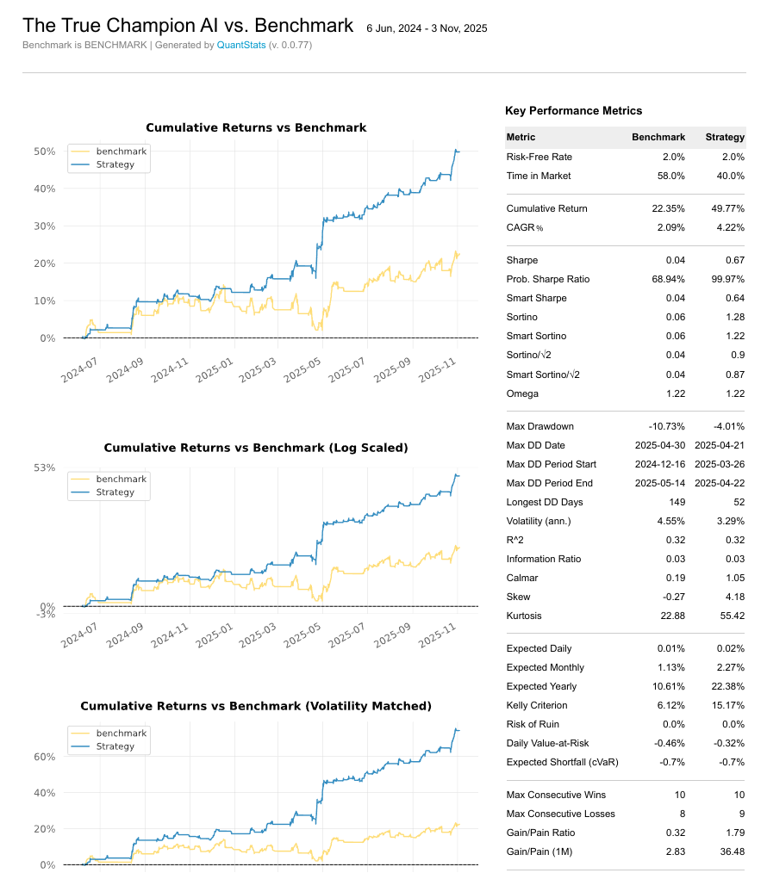

Part 2 -Report – The Champ vs Pure Mechanical Benchmark
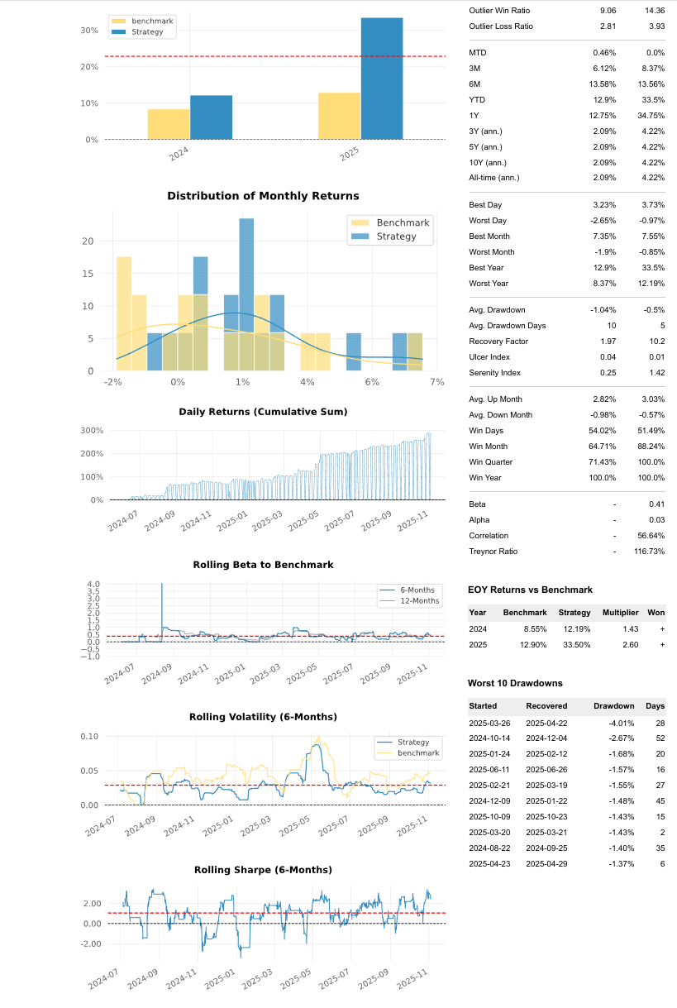

Report – Part 1 -LSTM-EMA-ATR vs BUY and HOLD
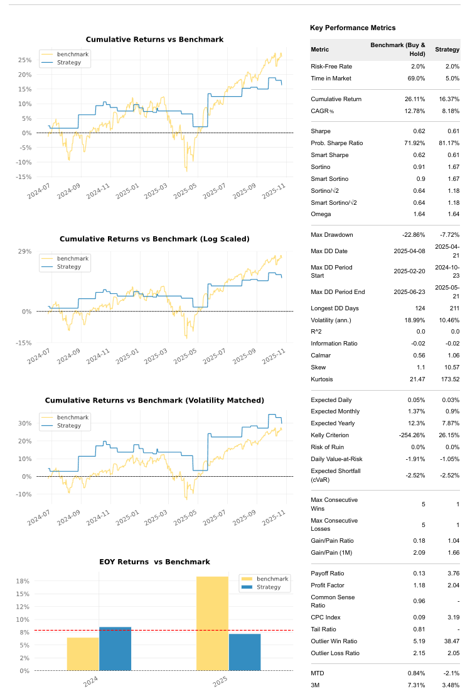

Part 2 -Report-LSTM-EMA-ATR vs BUY and HOLD
